**PROJECT REPORT**

**ON**

**Data Analysis On Start-up Funding**

**SUBMITTED BY**

**(Mandar Mahendra Makhi)**

**UNDER THE GUIDANCE OF**

**PROF. NILOFAR SHAIKH**

**SUBMITTED IN THE PARTIAL FULFILMENT OF**

**MSc COMPUTER SCIENCE Semester IV**

**FOR THE ACADEMIC YEAR 2019-2020**

**UNIVERSITY OF MUMBAI**

Department of Computer Science



S.I.E.S(Nerul) College of Arts, Science and Commerce,

Navi Mumbai-400706

 

SIES (NERUL) COLLEGE OF ARTS, SCIENCE AND COMMERCE

NAAC ACCREDITED ‘A’ GRADE COLLEGE (ISO 9001:2015 CERTIFIED INSTITUTION) NERUL, NAVI MUMBAI - 400706



THIS IS TO CERTIFY THAT THE PROJECT TITLED

Mandar Mahendra Makhi

IS UNDERTAKEN BY

PROF. NILOFAR SHAIKH

Seat No: 4104631

In partial fulfillment of the MSc - IT / CS Degree (Semester IV ) Examination in the academic year 2019-20 and has not been submitted for any other examination and does not form part of any other course undergone by the candidate. It is further certified that he/she has completed all the required phases of the Project.

Project Guide External Examiner

Head of Department Principal

**ACKNOWLEDGEMENT**

I have taken efforts in this project research. It would not have been possible without the kind support and help of many individual and organization. I would like to extend my sincere thanks to all of them.

I owe my profound gratitude to my project guide Asst Professor Nilofar shaikh who took keen interest on our project work and guided us all along. Big Data was a new subject for us and the concepts within it was made simpler and was well explained by our teacher.

I am thankful to and fortunate enough to get constant encouragement, support and guidance from all Teaching staffs of Department of computer science which helped us in successfully gathering the project requirements. Also, I would like to extend our sincere regards to all the non-teaching staff of department of computer science for their timely support.

Data Analysis

on

Start-up Funding

**TABLE OF CONTENT**

|  |  |
| --- | --- |
| **1** | **Introduction** |
| **2** | **Implementation Details** |
| **3** | **Data Analysis** |
| **4** | **Machine Learning Models** |
| **5** | **Future Enhancements** |
| **6** | **References** |

**INTRODUCTION**

A startup or start-up is a company or project initiated by an entrepreneur to seek, effectively develop, and validate a scalable business model. While entrepreneurship refers to all new businesses, including self-employment and businesses that never intend to grow big or become registered, startups refer to the new businesses that intend to grow large beyond the solo founder.Startups face high uncertainty and have high rates of failure, but a minority of them do go on to be successful and influential. Some startups become unicorns, i.e. privately held startup companies valued at over US$1 billion.

Startups typically begin by a founder (solo-founder) or co-founders who have a way to solve a problem. The founder of a startup will begin market validation by problem interview, solution interview, and building a minimum viable product (MVP), i.e. a prototype, to develop and validate their business models. The startup process can take a long period of time (by some estimates, three years or longer), and hence sustaining effort is required. Sustaining effort over the long term is especially challenging, because of the high failure rates and uncertain outcomes.

A startup is a young company founded by one or more entrepreneurs in order to develop a unique product or service and bring it to market. By its nature, the typical startup tends to be a shoestring operation, with initial funding from the founders or their families.

**KEY TAKEAWAYS**

* A startup is an entrepreneurial venture in search of enough financial backing to get off the ground.
* The first challenge for a startup is to prove the validity of the concept to potential lenders and investors.
* Startups are always risky propositions but potential investors have several approaches to determining their value.
* One of the startup's first tasks is raising a substantial amount of money to further develop the product. In order to do that, they have to make a strong argument, if not a prototype, that supports their claim that their idea is truly new or better than anything else on the market.

**Understanding the Startup**

In the early stages, startup companies have little or no revenue coming in. They have an idea, and they have to develop it, test it, and market it. That takes considerable money, and startup owners have several potential sources to tap.

Traditional funding sources include small business loans from banks or credit unions, government-sponsored Small Business Administration loans from local banks, and grants made by non-profit organizations and state governments.

So-called incubators, often associated with business schools and other non-profit’s, provide mentoring, office space, and seed funding to startups.

Venture capitalists and angel investors actively seek out promising startups to bankroll in return for a stake in the company once it gets off the ground.

**Valuing the Startup**

Startups have no history and less profit to show. That makes investing in them risky. If an idea seems to have merit, potential investors may use any of several approaches to estimate how much money it could take to get it off the ground.

The cost to duplicate approach looks at the expenses the company has already incurred to develop its product or service and purchase physical assets. This valuation method doesn't consider the company's future potential or intangible assets.

The market approach considers the acquisition costs of similar companies in the recent past. This approach may be stymied if the startup idea really is unique.

The discounted cash flow approach looks at the company's expected future cash flow. This approach is highly subjective.

The development stage approach assigns a higher range of potential value to a startup that is more fully developed. Even if it's not profitable, a startup that has a website and can show some sales and traffic would get a higher valuation than one that merely has an interesting idea.

Because startups have a high failure rate, would-be investors consider the management team's experience as well as the idea. Even angel investors don't invest money they cannot afford to lose.

**Some Successful Startups**

Some of history's most successful entrepreneurs created startups called Microsoft, founded by Bill Gates, Ford Motors, founded by Henry Ford, and McDonald's, founded by Ray Kroc.

Here are some startups that you may not have heard of yet, but LinkedIn bets that you will someday. They are among its picks for 2018's Top Startups.

Rubrik, a cloud data management company founded in 2014

Aurora, a developer of hardware and software for self-driving vehicles

Glossier, a skincare and beauty product company

Ripple, a network that uses blockchain technology to process currency exchange transactions

**Why Startups?**

Startups are “optimal” vehicles to validate and bring new innovations to the markets. Especially more disruptive innovations. Startups encapsulate all but only relevant things for what's needed to build new innovations with minimum “wasted resources” combined with maximum drive & motivation.

Startups create most of new jobs, attract international talent and foreign direct investments. “Over the last twenty-five years, almost all of the private sector jobs have been created by businesses less than five years old. Between 1988 and 2011, companies more than five years old destroyed more jobs than they created in all but eight of those years.” - Source: study by Kauffman Foundation and the Institute for Competitiveness & Prosperity

**Ideas are cheap. Execution is everything. It’s all about the people,’ I only invest when I think I have found the right team for the right business.” – Chris Sacca**

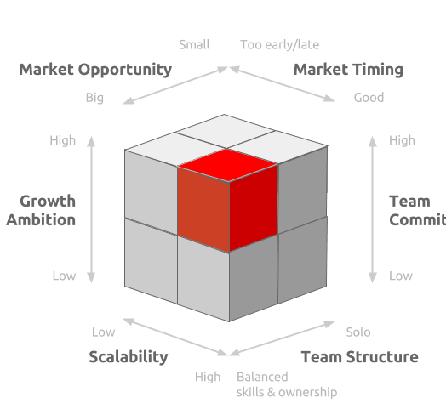

**Action Plan of Startup India Scheme**

The action plan of Startup India is based on the following factors:

**1. Simplification of Work**

This initiative simplifies the work for the new entrants in order to motivate them. This includes following steps taken by the government:

Firstly, the government has set-up Startup India hubs where all the works related to incorporation, registration, grievance handling, etc.

Secondly, an application and an online portal is set-up by the government to facilitate registration from anywhere and anytime.

Thirdly, the patent acquisition and registration is now fast for the startups.

Lastly, according to the Insolvency and Bankruptcy Bill, 2015 facilitates fast winding up of the startups. A new startup can wind-up itself within 90 days of the incorporation.

**2. Finance Support**

In order to motivate the startups, the government provides various financial supports. These steps taken by the government are as follows:

The government has set up a corpus of Rs.10,000 crores for 4 years (Rs.2500 crore each year). From such fund, the government invests in various startups.

Special funds are provided, investment in which leads to exemption from the income tax on the Capital Gain.

Income tax exemption is available for the startups for the first 3 years after the incorporation.

Under The Income Tax Act, where a Startup (company) receives any consideration for issue of shares which exceeds the Fair Market Value of the shares, such excess consideration is taxable in the hands of the recipient as Income from Other Sources.

Investment by venture capital funds in Startups is exempted from the application of this provision. The same extends to the investment made by incubators in the Startups.

You can get all the notifications of Startup India action plan here.

**Browse more Topics under Government Initiatives For Business Development**

• SETU (Self Employment and Talent Utilization)

**Benefits of Startup India**

• Financial Benefits

• Income Tax Benefits

• Registration Benefits

• Government Tenders

• Huge Networking Opportunities

**1. Financial Benefits**

Most of the startups are patent based. It means they produce or provide unique goods or services. In order to register their patents, they have to incur a heavy cost which is known as the Patent Cost.

Under this scheme, the government provides 80% rebate on the patent costs. Moreover, the process of patent registration and related is faster for them. Also, the government pays the fees of the facilitator to obtain the patent.

**2. Income Tax Benefits**

Startups enjoy a good amount of benefits under the Income Tax head. The government exempts their 3 years income tax post the incorporation year.

But they can avail it only after getting a certificate from the Inter-Ministerial Board. Also, they can claim exemption from tax on Capital Gains if they invest money in specified funds.

3. Registration Benefits

Everyone believes that incorporation and registration of business are far more difficult than running it. It is because of the long and complex steps of registration.

Under the Startup India scheme, an application is there to facilitate registration. A single meeting is arranged to at the Start-up India hub. Also, there is a single doubt and problem-solving window for them.

**4. Government Tenders**

Everyone seeks to acquire Government tenders because of high payments and large projects. But it is not easy to acquire the government tenders.

Under this scheme, the startups get priority in getting government tenders. Also, they are not required to have any prior experience.

**5. Huge Networking Opportunities**

Networking Opportunities means the opportunity to meet with various startup stakeholders at a particular place and time. The government provides this opportunity by conducting 2 startups fests annually (both at domestic as well as the international level).

Startup India scheme also provides Intellectual Property awareness workshop and awareness.

**Registration of the Startup can be done only from following types of companies**

1. Partnership Firm

2. Limited Liability Partnership Firm

3. Private Limited Company

**Eligibility for Registration under Startup India Scheme**

1. Firstly, the company to be formed must be a private limited company or a limited liability partnership firm.

2. Secondly, the firms should have obtained approval from the Department of Industrial Policy and Promotion.

3. Thirdly, it must have a recommendation letter by an incubation.

4. The firm must provide innovative schemes or products.

5. It should be a new firm or not older than five years.

6. The total turnover of the company should be not exceeding 25 crores.

7. Lastly, it should not be a result of splitting up, or reconstruction, of a business already in existence.

**IMPLEMENTATION DETAILS**

**Challenges faced by startups in India**

* Lack of availability of quality funds for early stage startups, especially the ones seeking seed money (initial money).
* Lack of expertise or knowledge. Government policies keep on changing day to day basis Therefore, lack of adequate mentoring/guidance.
* Hiring and retaining good quality talent is challenging, especially in the areas of product and technology.
* Availability of loans by banks and other financial institutions at right time is also challenging.
* Lack of infrastructure facility in rural areas stopping startups to start over there.

**System Requirement Specification**

A software requirements specification is a description of a software system to be developed it lays out functional and non- functional requirements, and may include a set of use cases that describe the interaction that the software must provide.

software requirements specification establishes the basis for an agreement between customers. and contractors or suppliers (in market-driven projects. These roles may be played by the marketing and development divisions) on what software product is done as well as what is not expected to do, software requirements specifications permit a rigorous assessment of requirements Before the design can begin and reduces later redesign. It should also provide a realistic basis for estimating product costs, risks, and schedules

**System Specification:**

* **R**

R is a free and open source software programming language and software environment for statistical computing and graphics.

Distributed under the GNU General Public License version 2, R is an easy language to learn and commonly used for developing data analysis and statistical software. R compiles and runs on a wide variety of UNIX platforms, Windows and MacOS.

R is designed to allow users to add additional functionality by defining new functions. Much of the system is itself written in the R dialect of the S programming language. For computationally-intensive tasks, C, C++ and Fortran code can be linked and called at run time. Advanced users can write C code to manipulate R objects directly. This programming language was named R, based on the first letter of first name of the two R authors (Robert Gentleman and Ross Ihaka), and partly a play on the name of the Bell Labs Language S.

* **Python**

Python is an interpreted, object-oriented, high-level programming language with dynamic semantics. Its high-level built in data structures, combined with dynamic typing and dynamic binding, make it very attractive for Rapid Application Development, as well as for use as a scripting or glue language to connect existing components together. Python's simple, easy to learn syntax emphasizes readability and therefore reduces the cost of program maintenance. Python supports modules and packages, which encourages program modularity and code reuse. The Python interpreter and the extensive standard library are available in source or binary form without charge for all major platforms, and can be freely distributed. Python has been built with extraordinary Python libraries that are used in Big Data every day for solving problems. which are following

* NumPy
* SciPy
* Pandas
* Matplotlib

This project main purpose to present decade, India is planning a vital shift in the direction of startup welcoming policies and a business-friendly or entrepreneur’s environment. India is one of the fastest growing countries in terms of entrepreneurship. Entrepreneurship is an essential input for economic development, creating new markets or opportunities. Currently, India is promoting entrepreneurship enthusiastically but it’s a huge challenge for government as well as large population of India to create employment via startups. This paper intention at offering an analytical overview of the boom and potentialities of startup systems in India i.e the progress made by India so far. Therefore, this research can contribute to a better understanding of the Investment and financing strategy of entrepreneurial ventures 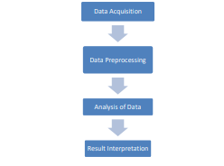

1. **Data collection**

Data used in this project is a set of startup funding in India of various startups. All the Data was Available on kaggle website. The dataset has one csv file. In this dataset available data 2015 to 2019. This dataset has the Startup funding related information of some of the top Startup funding company’s and top of the invester to provide fund.

This dataset has the following features:

SNo

Date

StartupName

IndustryVertical

SubVertical

CityLocation

Investorname

InvestmentnType

AmountinUSD

Remarks

State

1. **Data Preprocessing**

Data preprocessing consists of the following tasks:

• Data Cleaning

• Data Transformation

• Data Integration

• Data reduction Here data needs to be cleaned to avoid wrong conclusions.

For this task, we have identified the null values in each column. They are as follows:

Column Null Values

Remarks 1953

SubVertical 936

AmountInUSD 847

CityLocation 179

IndustryVertical 171

InvestorsName 8

InvestmentType

StartupName 0

Date 0

SNo 0

we can see Remarks have the most number of null values, 1953 null values, which is 82.3 % of the total remarks values. Therefore we will drop the column since it would not provide any useful information during the analysis. We would also need to fix some date formats, spelling typos, and combine alternate names of a company into a single name. Ex: 12/05.2015 to 12/05/2015, Seed Funding to Seed Funding, Ola to Ola Cabs, etc. The amount of investment column is present as ‘AmountInUSD’ column is separated by commas which must be removed so that mathematical operations could be applied over it.

1. **Analysis of Data**

You now have a nice dataset (or maybe several), so this is a good time to start exploring it by building graphs. When you’re dealing with large volumes of data, visualization is the best way to explore and communicate your finding

The data is analyzed using python libraries like pandas, numpy, dateutil etc. Using these and many other libraries in-depth analysis was possible.

**Data Analysis**

1: How does the funding ecosystem change with time? (Number of funding per month)

*## Cleaning the dates*

data['Date'][data['Date']=='12/05.2015'] = '12/05/2015'

data['Date'][data['Date']=='13/04.2015'] = '13/04/2015'

data['Date'][data['Date']=='15/01.2015'] = '15/01/2015'

data['Date'][data['Date']=='22/01//2015'] = '22/01/2015'

data['Date'][data['Date']=='05/072018'] = '05/07/2018'

data['Date'][data['Date']=='01/07/015'] = '01/07/2015'

data['Date'][data['Date']=='**\\\\**xc2**\\\\**xa010/7/2015'] = '10/07/2015'

*# some of the date formats are written wrongly so we have to clean them thoroughly so that we can analyze these values*

*# converting them into a Datetime object*

data["yearmonth"] = (pd.to_datetime(data['Date'],

format='**%d**/%m/%Y').dt.year*100)+(pd.to_datetime(data['Date'],format='**%d**/%m/%Y').dt.month)

temp = data['yearmonth'].value_counts().sort_values(ascending = False).head(10)

print("Number of funding per month in decreasing order(Top 10)**\n**",temp)

year_month = data['yearmonth'].value_counts()

*# lets plot the data*

plt.rcParams['figure.figsize'] = (15, 7)

sns.barplot(year_month.index, year_month.values, palette = 'copper')

plt.xticks(rotation = 90)

plt.xlabel('Year-Month of transaction', fontsize=12)

plt.ylabel('Number of fundings made', fontsize=12)

plt.title("Year-Month Distribution", fontsize=16)

plt.show()

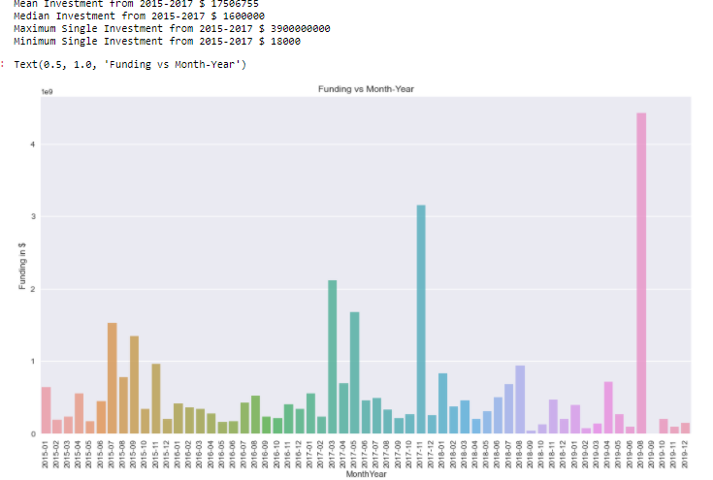

As we can see that startups got more funding in **January 2019** Above visualization shows how funding varies from one month to another.

**2:** **How much funds does startups generally get in India?(maximum funding, minimum funding , average funding and number of fundings)**

## Finding max Amount funding to start-up

print("Maximum funding to a Startups is : ", fund_withAmts ["AmountInUSD"].dropna().sort_values().max())

## Then find the which start-up will funded most amount

[funding_data.AmountInUSD == 3900000000.0]

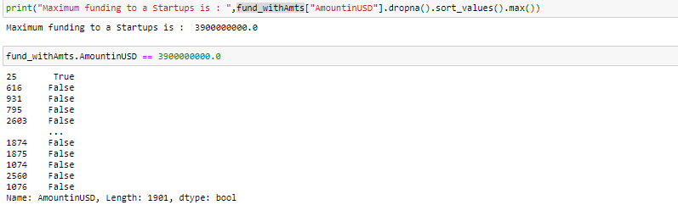

**Westbridge Capital have the max funding**

## Finding min Amount funding to start-up

print("Minimum funding to a Startups is : ", fund_withAmts ["AmountInUSD"].dropna().sort_values().min())

## Then find the which start-up will fund least amount

[funding_data.AmountInUSD == 16000.0]

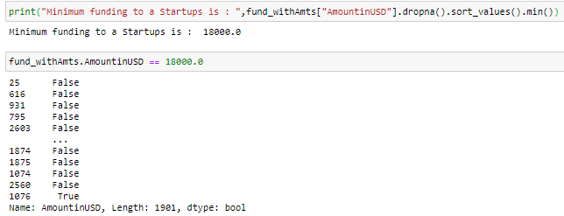

Now as we can see **The Ten Minute Million** are least funded Startups i.e, 18000 USD

## Finding Average Amount funding to start-up

print("On Average indian startups got funding of : ", fund_withAmts ["AmountinUSD"].dropna().sort_values().mean())

On an Average indian startups got funding of : 12031073.099016393

print("Total startups funded : ", len(funding_data["StartupName"].unique()))

print(funding_data["StartupName"].value_counts().head(10))

startupname = funding_data['StartupName'].value_counts().head(20)

plt.figure(figsize=(15,8))

sns.barplot(startupname.index, startupname.values, alpha=0.9, color=color[0])

plt.xticks(rotation='vertical')

plt.xlabel('Startup Name', fontsize=12)

plt.ylabel('Number of fundings made', fontsize=12)

plt.title("Number of funding a startup got", fontsize=16)

plt.show()

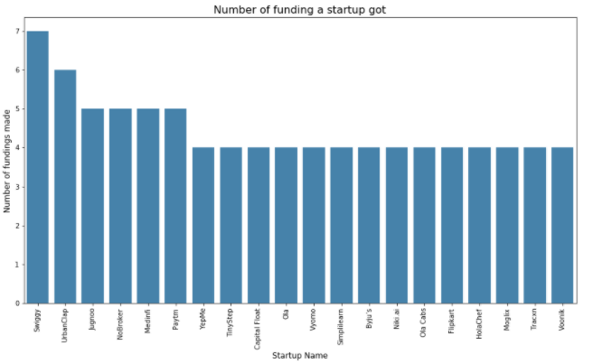

As we can see that **Swiggy** got maximum number of fundings(Total funding = 7) and total there are 2001 indian startups funded from January 2015 to August 2017. The above visulization is only for Top 20 startups.

**3 : Which industries are favored by investors for funding ? (OR) Which type of companies got more easily funding?**

industry = funding_data['IndustryVertical'].value_counts().head(10)

print(industry)

plt.figure(figsize=(15,8))

sns.barplot(industry.index, industry.values, alpha=0.9, color=color[0])

plt.xticks(rotation='vertical')

plt.xlabel('Industry vertical of startups', fontsize=12)

plt.ylabel('Number of fundings made', fontsize=12)

plt.title("Industry vertical of startups with number of funding", fontsize=16)

plt.show()

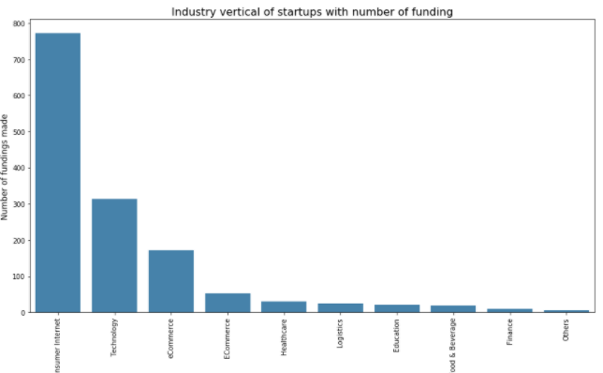

If we see Above **"Consumer Internet"**got maximum number of funding = 772 followed by technology and E-Commerce.

industry = funding_data['SubVertical'].value_counts().head(10)

print(industry)

plt.figure(figsize=(15,8))

sns.barplot(industry.index, industry.values, alpha=0.9, color=color[0])

plt.xticks(rotation='vertical')

plt.xlabel('Subvertical of startups', fontsize=12)

plt.ylabel('Number of fundings made', fontsize=12)

plt.title("Subvertical of startups with number of funding", fontsize=16)

plt.show()

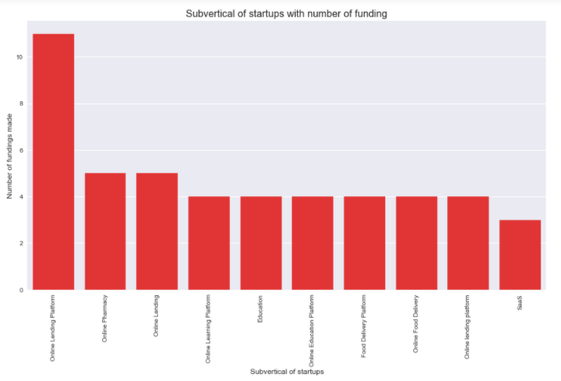

In Subcategores, **"Online learning platformer "** got maximim number of fundings.

**4 : Do cities play a major role in funding ? (OR) Which city has maximum start-ups ?**

city = funding_data['CityLocation'].value_counts().head(10)

print(city)

plt.figure(figsize=(15,8))

sns.barplot(city.index, city.values, alpha=0.9, color=color[0])

plt.xticks(rotation='vertical')

plt.xlabel('city location of startups', fontsize=12)

plt.ylabel('Number of fundings made', fontsize=12)

plt.title("city location of startups with number of funding", fontsize=16)

plt.show()

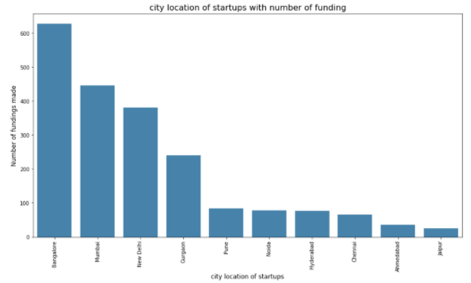

**Distribution of startups across Top different cities**

plt.figure(figsize=(15,8))

count = funding_data['CityLocation'].value_counts()

squarify.plot(sizes=count.values,label=count.index, value=count.values)

plt.title('Distribution of Startups across Top cities')

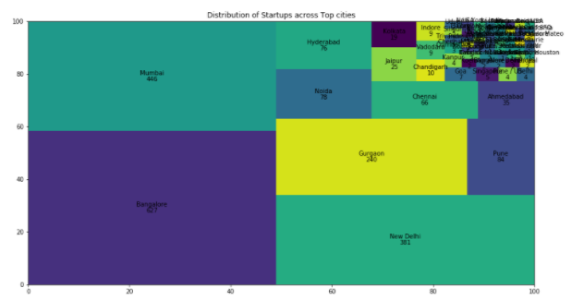

We can see **Bangalore** attracts more number of investor’s followed by **Mumbai** and **New** **Delhi**

## 5 : Who is the important investors in the Indian Ecosystem?

from wordcloud import WordCloud

names = funding_data["InvestorsName"][~pd.isnull(funding_data["InvestorsName"])]

*#print(names)*

wordcloud = WordCloud(max_font_size=50, width=600, height=300).generate(' '.join(names))

plt.figure(figsize=(15,8))

plt.imshow(wordcloud)

plt.title("Wordcloud for Investor Names", fontsize=35)

plt.axis("off")

plt.show()

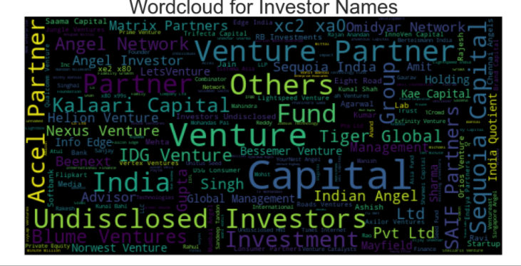

print(investors)

plt.figure(figsize=(15,8))

sns.barplot(investors.index, investors.values, alpha=0.9, color=color[0])

plt.xticks(rotation='vertical')

plt.xlabel('Investors Names', fontsize=12)

plt.ylabel('Number of fundings made', fontsize=12)

plt.title("Investors Names with number of funding", fontsize=16)

plt.show()

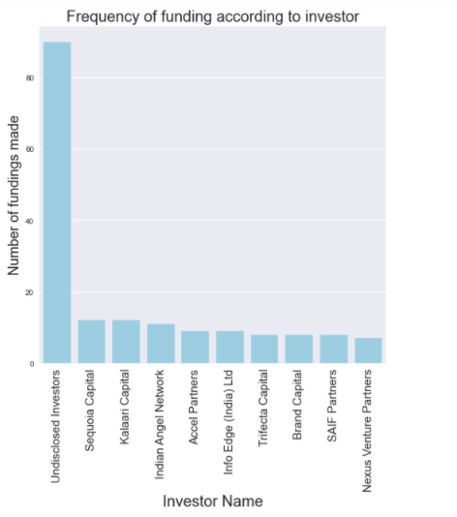

**Undisclosed investor & Indian Angel network**and**Ratan tata** funded maximum number of startups followed by **Kalaari Caitals**.

## 6 : What are different types of funding for startups ?

investment = funding_data['InvestmentType'].value_counts()

print(investment)

investment = funding_data['InvestmentType'].value_counts()

print(investment)

plt.figure(figsize=(15,8))

sns.barplot(investment.index, investment.values, alpha=0.9, color=color[0])

plt.xticks(rotation='vertical')

plt.xlabel('Investment Type', fontsize=12)

plt.ylabel('Number of fundings made', fontsize=12)

plt.title("Investment Type with number of funding", fontsize=16)

plt.show()

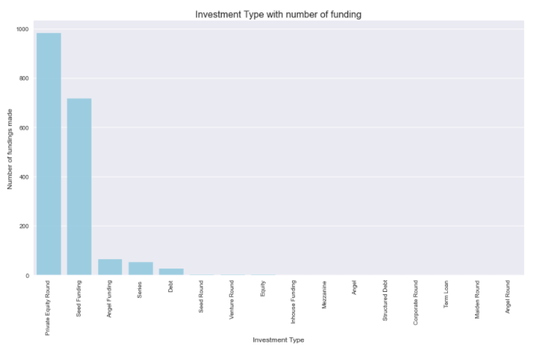

We can see **Seed Funding** is in **Top** followed by Private Equity.

**Machine Learning Models**

To ease our job we will create a class

This class has function based on various machine learning algorithm

.

**Linear Regression**

**Linear regression** is a common Statistical Data Analysis technique. It is **used** to determine the extent to which there is a **linear** relationship between a dependent variable and one or more independent variables. ... The difference between the two is the number of independent variables

RMSE-train 0.000

RMSE-test 14125607.683

Accuracy Train: 1.000 Test: 0.149

Out[43]:

(1.2121515030677964e-07, 14125607.68324172)

Testing Validation

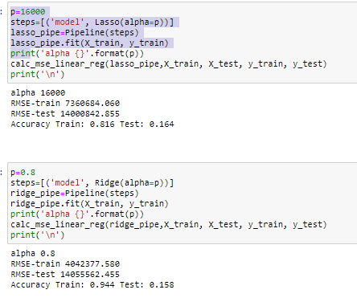

**Decision tree** builds **regression** or **classification** models in the form of a **tree** structure. It breaks down a dataset into smaller and smaller subsets while at the same time an associated **decision tree** is incrementally developed. The final result is a **tree** with **decision** nodes and leaf nodes.

[0.15041632 0.07270791 0.1161707 0.17375903 0.11319069]

Test Score 0.198

Test Error 13755110.486

Train Score 0.138

Train Error 15792629.017

Out[52]:

DecisionTreeRegressor(max_depth=2, max_features='sqrt',

min_weight_fraction_leaf=0.002, random_state=9)

Decision tree builds regression or classification models in the form of a tree structure. It breaks down a dataset into smaller and smaller subsets while at the same time an associated decision tree is incrementally developed. The final result is a tree with **decision nodes** and **leaf nodes**. A decision node (e.g., Outlook) has two or more branches (e.g., Sunny, Overcast and Rainy), each representing values for the attribute tested. Leaf node (e.g., Hours Played) represents a decision on the numerical target. The topmost decision node in a tree which corresponds to the best predictor called **root node**. Decision trees can handle both categorical and numerical data.

**Random Forest Regressor**

**Random Forest Regression** is a supervised learning algorithm that uses **ensemble learning** method for regression. Ensemble learning method is a technique that combines predictions from multiple machine learning algorithms to make a more accurate prediction than a single model



**CONCLUSION**

The conclusion obtained from the analysis and visualization for the ‘Indian Start-up Funding’ data is the trends of how the events like Digital India initiative, Start-up India, Indian money demonetization and surgical strike affected the funding by investors into the companies. Also, it is observed that even though tier-II and tier-II cities attracted some investors still tier-I cities like Bangalore, Mumbai, and Delhi leads the way for maximum investments. Unicorns like Flipkart and Paytm still attract investors due to its position in the market. And after demonization Paytm adopted the cashless India policy to boost their revenue. Ola cabs and Swiggy attracted the most investors in the two years and both are planning to join the unicorn clubs. Still today Consumer internet is more fevered to investors than any other industry verticals, but to the due advancement of AI, Machine learning, and other advancements in technology, the technology vertical has also attracted a large number of investors. With consumer internet leading the way, its sub-verticals like online pharmacy, online lending platform, online payment gateway, etc have also attracted the greatest number of investors. Since India has become a hub for start-up’s, new start-up emerges, therefore, seed funding is important for then, therefore, seed funding is the most preferred type of investment. The single most common reason for an investment amount remaining undisclosed is that the size of the round would be viewed by the market as derisory in comparison to competitors. This is particularly common at the seed stage. Therefore there is a number of undisclosed investors in the data. In recent years India has attracted a lot of foreign investors like Sequoia Capital, Accel Partners, and others, out of which Sequoia Capital and Accel partners lead the pack with most investment meaning foreign investors invest more than Indian investors. An interesting point to take is that individuals like Ratan Tata have taken a keen interest in investing in startups since they invested more than any other individuals. With the visualizations, we came to know that various events do affect the funding. Also the cities and industry verticals play an important part in acquiring funding from investors, and foreign investors invest a lot into Indian startups.

**Future Enhancement**

In order to meet the objectives of the initiative, Government of India Action Plan that addresses all aspects of the Startup ecosystem has been announced. With this Action Plan the Government hopes to accelerate spreading of the Startup movement:

* From digital/ technology sector to a wide array of sectors including agriculture, manufacturing, social sector, healthcare, education, etc.
* From existing tier 1 cities to tier 2 and tier 3 cities including semi-urban and rural areas.

The Action Plan is divided across the following areas:

* Simplification and Handholding
* Funding Support and Incentives
* Industry-Academia Partnership and Incubation

**REFERENCES**

• Determinant of Start-ups’ Fund-raising Value: Entrepreneur and Firm Characteristic

• Start-up Funding via Equity Crowdfunding in Germany – A Qualitative Analysis of Success Factors

• "Startup valuation by venture capitalists: an empirical study."

• "Determinants of start-up firm external financing." Journal of Banking & Finance

• "Key value drivers of startup companies in the new media industry—The case of online games in Korea."

• Analysis of financing sources for start-up companies

• Google

• YouTube

• Kaggle